# Inside look at modern web browser (1)

## CPU,GPU,Memory, and multi-process architecture

In this 4-part blog series, we’ll look inside the Chrome broswer from high-level architecture to the specifics of the rendering pipeline. If you ever wondered how the browser turns your code into a functional website, or you are unsure why a specific technique is suggested for performance improvements, this series is for you.

As part 1 of this seris, we’ll take a look at core computing terminology and Chrome’s multi-process architecture.

Note: If you are familiar with the idea of CPU/GPU and process/thread you may skip to [Browser Architecture](https://developers.google.com/web/updates/2018/09/inside-browser-part1" \l "browser-architecture) .

## At the core of the computer are the CPU and GPU

In order to understand the environment that the browser is running, we need to understand a few computer parts and what they do.

### CPU

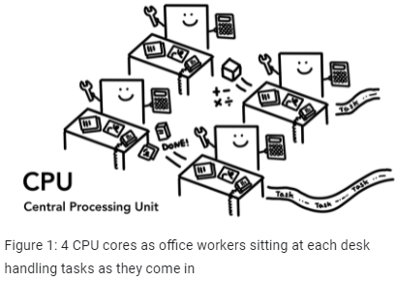First is the **C**entral **P**rocessing **U**nit-or **CPU**. The CPU can be considered your computer’s brain. A CPU core, pictured here as an office worker, can handle many different tasks one by one as they come in. It can handle everything from math to art while knowing how to reply to a customer call. In the past most CPUs were a single chip. A core is like another CPU living in the same chip. In mordern hardware, you often get more than one core, giving more computing power to your phones and laptops.

### GPU

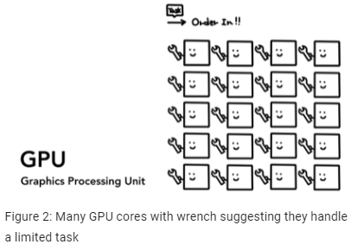**G**raphics **P**rocessing **U**nit - or **GPU** is another part of the computer. Unlike CPU, GPU is good at handling simple tasks but accross multiple cores at the samie time. As the name suggests, it was first developed to handle graphics. This is why in the context of graphics “using GPU” or “GPU-backed” is associated with fast rendering and smooth interaction. In recent years, with GPU-accelerated computing, more and more computation is becoming possible on GPU alone.

When you start an application on your computer or phone, the CPU and GPU are the ones powering the application. Usually, applications run on the CPU and GPU using mechanisms provided by the Operating System.

